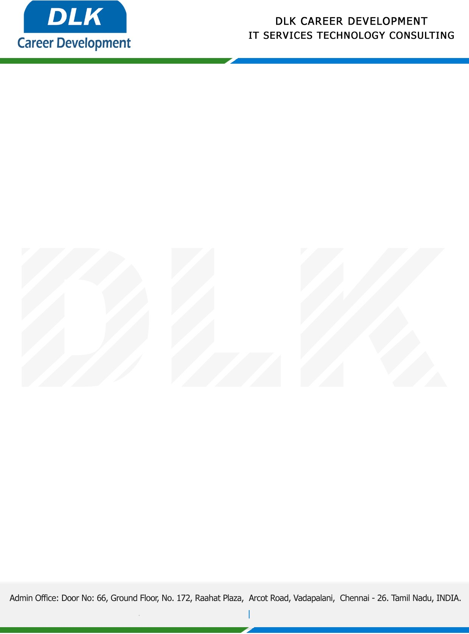

Date: 12 / December/ 2022

**To**

Department of BCA ([Computer Application),](https://www.cseindia.org/)

Head of Department,

Dr.MGR Educational and Research Institute University in Chennai-600095

**Sub: Letter of Project Acceptance**

This is to certify final year student of has accepted the Project Work duration from **14st December 2022** to **20th February 2023** under the domain **“MULTIMEDIA”.** During the project, all information and data collected from you should be kept confidential.

**Team members:**

1. **ADITHYA KUMAR V (REG NO: 204011101009)**
2. **TYSON ANTONY A J (REG NO: 204011101353)**
3. **KAMESH M (REG NO: 204011101134)**
4. **YADHAVESHWARAN M (REG NO: 204011101392)**
5. **DHARSHINI A (REG NO: 204011101064)**

**Topic:** Minimization of Misinformation Influence in Online Social Networks

We appreciate your interest in **DLK CAREER DEVELOPMENT**

